We are excited to hear about your interest in the Respiratory Therapy Program at Snow College! Entry into the Respiratory Therapy Program at Snow College requires the following steps.

1 | Meet with a Concurrent Enrollment Advisor and Apply to Snow College
Complete or plan the following prerequisite courses:
- - BIOL 1610 - Biology I
- - CHEM 1110 - Elementary Chemistry
- - ENGL 1010 - Introduction to Writing
- - MATH 1030 or higher - Quantitative Reasoning or above
- - BIOL 2320/2325 - Human Anatomy + Lab
- - BIOL 2420/2425 - Human Physiology + Lab
Advisors by Region:
Bree Daniels | Juab, North Sanpete, Delta, Millard
Phone: 435.851.9253 | Email: bree.daniels@snow.edu
Christi Orme | Cedar Ridge, Emery, Kanab, North Sevier, Panguitch, Piute, Richfield, South Sevier, Wayne
Phone: 435.531.4162 | Email: christi.orme@snow.edu
Meagan Dyreng | Gunnison, Manti
Phone: 435.660.1857 | Email: meagan.dyreng@snow.edu
Apply to Snow College: https://www.snow.edu/admissions/

2 | Contact the Pre-Respiratory Therapy Advisor
Sheila Smith, Pre-RT Advisor
Phone: 435.283.7332 | Email: sheila.smith@snow.edu
Schedule an advising appointment: https://outlook.office365.com/book/SheilaSmith@snow.edu/

3 | Complete the Respiratory Therapy Program Application
Applications for the first cohort (starting January 2026) will open soon!
To receive updates and be notified when the application is live, click on the link or scan the QR code to fill out the Interest Form below:
Interest Form
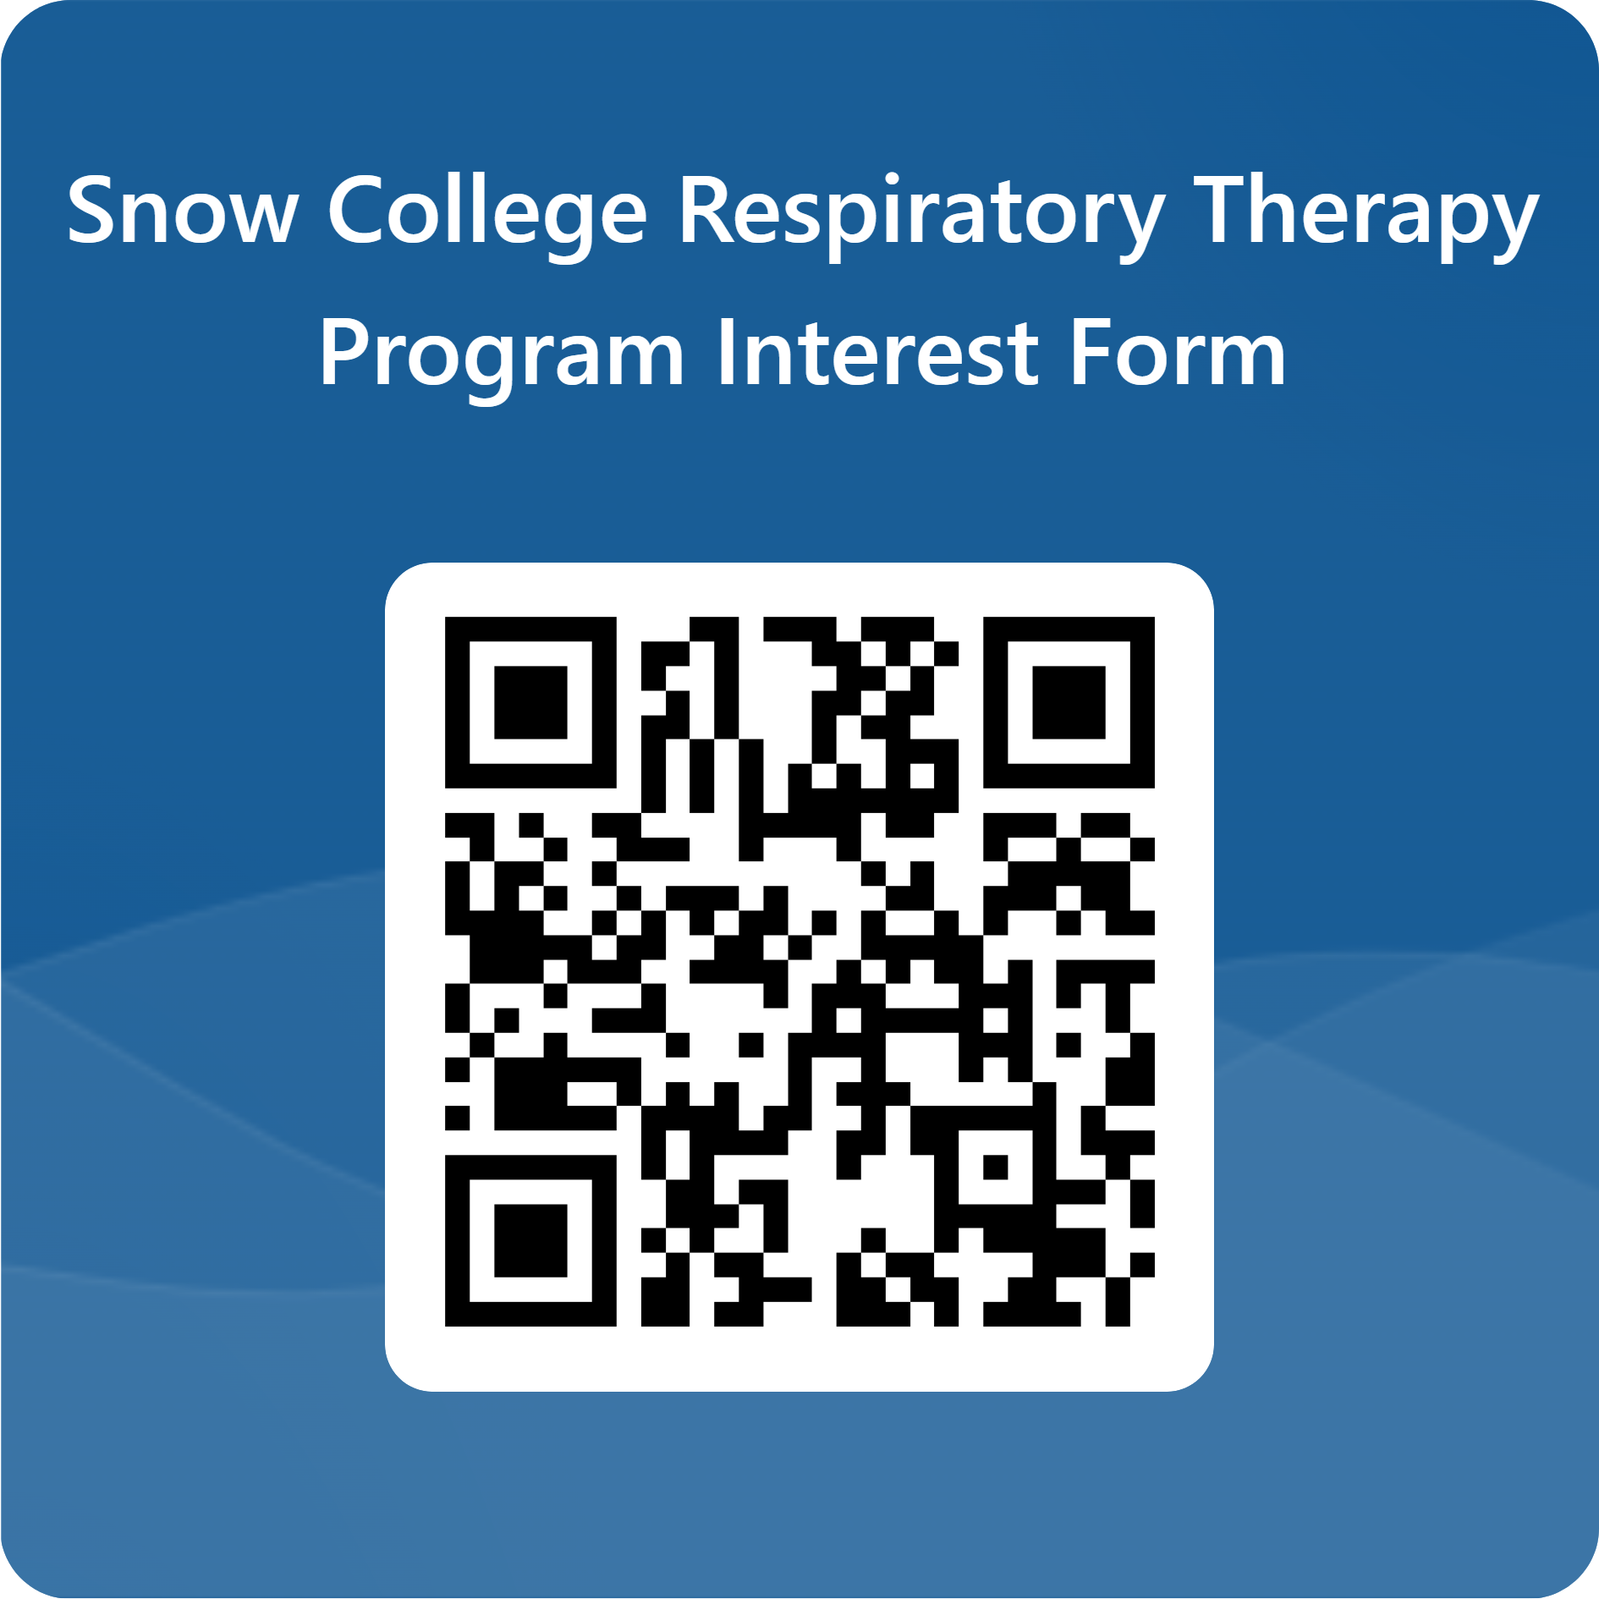

Program Contact
Kelly Rose, MSHS, RRT, AE-C
Respiratory Therapy Program Director
Phone: 435.283.7602 | Email: kelly.rose@snow.edu
Visit the Respiratory Therapy Program Website: https://snow.edu/academics/programs/respiratory-therapy.html

